Experiment No: 2

Title: Use var, let, const, and demonstrate basic features like template literals and destructuring; build a billing calculator with user input.

Software/Tools Required: Visual Studio Code (or any text editor), Web Browser (Google Chrome, Microsoft Edge, Firefox, etc.)

Theory:
JavaScript provides three keywords to declare variables: var, let, and const.
1. var
- var is function-scoped.
- Variables declared with var can be redeclared and updated.
- It is hoisted and initialized with undefined.
- Generally avoided in modern JavaScript because it may cause unexpected behavior.
2. let
- let is block-scoped.
- Variables can be updated but cannot be redeclared within the same scope.
- Preferred for variables whose values change.
3. const
- const is also block-scoped.
- Variables cannot be reassigned after initialization.
- Used for fixed values..
Billing Calculator
A billing calculator is a JavaScript application that accepts user input such as customer name, product name, quantity, and price. It calculates the subtotal, applies any discount or GST if required, and displays the final payable amount using template literals and modern JavaScript features like let, const, and destructuring.

Output:
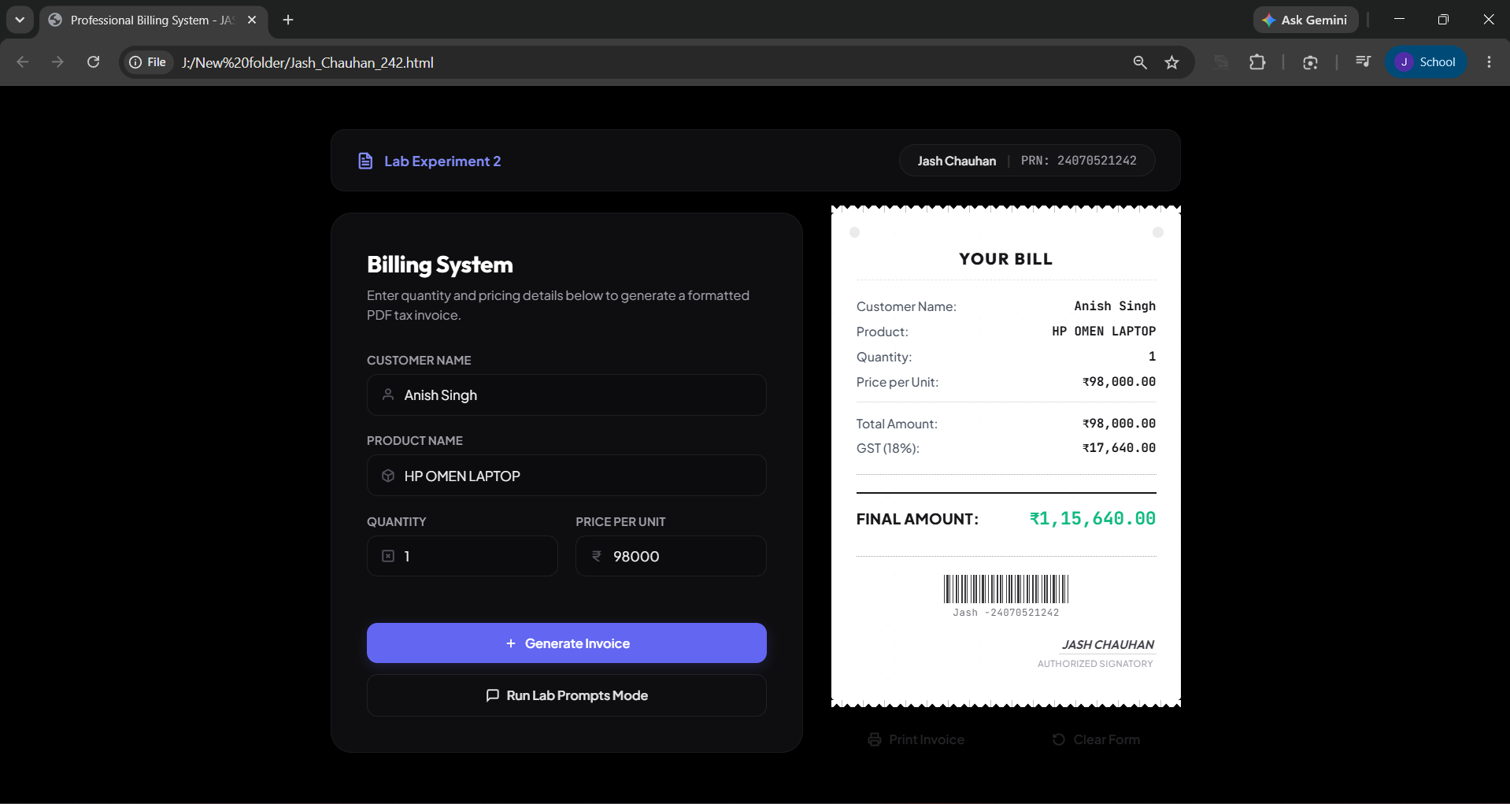

Result/Conclusion:
The experiment was successfully completed. The concepts of var, let, and const were understood and implemented. Template literals were used to display formatted output, and destructuring simplified data extraction from objects. A billing calculator was successfully developed to accept user input, calculate the bill with GST, and display the final amount accurately.

